Detection and Prevention of Advanced Persistent Threat (APT) activities in heterogeneous networks using Deep Learning

1Dharaneish V C   
*Department of Computer Science and Engineering (CSE)*  
*Amrita Vishwa Vidyapeetham*Coimbatore - 641112, India   
[dharaneishvc@gmail.com](mailto:dharaneishvc@gmail.com)

4Dr. Senthil Kumar T  
*Department of Computer Science and Engineering (CSE)*  
*Amrita Vishwa Vidyapeetham*Coimbatore - 641112, India  
[t_senthilkumar@cb.amrita.edu](mailto:t_senthilkumar@cb.amrita.edu) 2Nithin Kumar  
*Department of Computer Science and Engineering (CSE)*  
*Amrita* *Vishwa Vidyapeetham*Coimbatore - 641112, India  
[itsnithinkumar@gmail.com](mailto:itsnithinkumar@gmail.com)

5Sulakshan Vajipayajula  
*Architect – CTO, IBM Security*  
*IBM India Pvt Ltd*Bengaluru, India   
[svajipay@in.ibm.com](mailto:svajipay@in.ibm.com)

7Kartik Srinivasan  
*Sr. Architect, IBM Security*  
*IBM India Pvt Ltd*  
[kartiksr@in.ibm.com](mailto:kartiksr@in.ibm.com)

3Hari Varsha  
*Department of Electrical and Electronics Engineering(EEE)*  
*Amrita Vishwa Vidyapeetham*Coimbatore - 641112, India  
[v.harivarsha@gmail.com](mailto:v.harivarsha@gmail.com)

6Anjali Tibrewal  
*Sr. Architect, IBM Security*  
*IBM India Pvt Ltd*  
[anjtibre@in.ibm.com](mailto:anjtibre@in.ibm.com)

*Abstract*—Security vulnerabilities and breaches caused by malicious software attacks are a major security concern in this digital age. Malware detection continues to be a hot topic as many computer users, networks, organizations, businesses and governments are affected by the rapid growth of malware attacks. Many intrusion detection Systems have been developed to protect the data and resources from attacks. But still, new attacks and threats are developed every day, making it more difficult to these systems to detect those attacks. Not only the system has to detect an attack, but also it should prevent the attacks in network. To achieve this purpose an Advanced Persistent Threat detection system based on Deep Learning model can be developed as it has the potential to perform better in extracting features of data considering the massive cyber traffic in real life. In order to determine the efficiency of identifying anomalies, this work aims to examine deep learning artificial neural network algorithms like Convolutional Neural Network (CNN), Long Short-Term Memory (LSTM), Gated Recurrent Unit (GRU) and Recurrent Neural Network (RNN) and compare their efficiency in this research. Based on the various evaluation metrics, CNN emerged out as the best model among four.

Keywords—Deep Learning, Artificial Neural Networks, Malware Detection, Intrusion detection system, Data Mining, Convolutional Neural Networks (CNN), Gated Recurrent Unit (GRU), Long Short-Term Memory (LSTM), Recurrent Neural Networks (RNN)

# Introduction

Advanced Persistent Threat (APT) is a type of cyberattack that is carried out by a group, often nation states or state-sponsored organizations, where a hacker gains unauthorized access to a computer network and remains undetected for an extended period of time. APT is one of the major information security threats that industry is currently facing. APT attacks are particularly dangerous because they target an organization's sensitive data and exfiltrate the data to remote hosts. APT attacks are typically carried out by highly skilled and well-funded attackers, making them extremely difficult to detect and prevent using traditional security measures. Notable examples of APT attacks include the loss of 40 GB of Ashley Madison's database in 2015 and the theft of 9 GB of encrypted password data from Adobe Leak in 2013.

Conventional techniques for detecting APT attacks are inadequate when such attacks occur in a dynamic and complex infrastructure like the cloud. These attacks are challenging to identify due to their long-lasting nature on the network, and the possibility that the system would crash owing to the enormous traffic. Moreover, APT attacks often maintain their anonymity and frequently employ Zero-Day attack, a type of cyberattack that exploits a software security flaw that the developer may be unaware of. As a result, existing Intrusion Detection System solutions are unable to identify APTs. For many years, most of these attacks go unreported, like the Red October APT attack that has been operating for more than five years.

To detect and defend against APT-type attacks before exfiltration occurs, network intrusion systems using new Deep learning techniques and relevant analytical tools must be developed. The network intrusion detector is a predictive model that distinguishes between intrusions or attacks and normal connections. Deep learning is preferred due to its capacity to thoroughly analyse network data and automatically produce the feature vector. Deep learning algorithms greatly improve the performance of network intrusion detection systems by producing higher detection rates and lower false alarm rates.[1]

Both straightforward and sophisticated neural network models have been developed to identify cyberattacks on hosts and network systems. Deep learning is highly preferred due to its ability to examine the computer process that replicates the normal activity of the human brain. Therefore, to effectively detect and defend against APT attacks, new network intrusion detection systems utilizing deep learning algorithms and analytical tools must be developed.[2][3]

## Roadmap

The paper is structured as follows: in Section II, an overview of the existing intrusion detection systems is presented. Section III outlines the preliminaries of the work and the proposed methodology, including the architectures. The Experiment and Analysis section, Section IV, provides details on the dataset used, while Section V presents the results and comparative analysis. The conclusion and future research directions are discussed in Section VI.

# Related Works

This section examines the existing Intrusion Detection Systems(IDS), APT attack methods, and the challenges faced by them. IDS is a security tool that monitors a system or network for malicious activities or policy violations. The objective of an IDS is to identify security events and provide alerts for security analysts to investigate and respond to potential security breaches.

Currently, APT attacks can be detected using tools like User and Entity Behaviour Analytics UEBA, deception technology, and network monitoring. In recent trends many Machine learning algorithms like Decision tree, Bayesian network, Support Vector Machine have been employed and those gave a reasonable Accuracy, sensitivity, specificity and F1 Score.[4][5][6]

Designing an APT (Advanced Persistent Threat) Intrusion Detection System using machine learning is challenging due to limited availability of real-time and good dataset, data imbalance, dynamic nature of APTs, limited interpretability, and false positives. The lack of proper innovative methodology and a lack of crucial elements such as ground-truth labels and publicly available datasets make it difficult to build production level systems. Anomaly detectors have a high false alarm rate while trying to identify unknown assaults like zero-day attacks. System evolution makes it more challenging to define typical behaviour, which might reduce detection performance. Addressing these challenges requires a combination of expertise in cybersecurity, data science, and machine learning.

Khalid et al. [7] outlines the main challenges associated with detecting Advanced Persistent Threats (APT), including the attackers' determination and resources, the long duration of attacks, potential internal threats, the attackers' powerful resources, and the complexities of cloud computing infrastructure.

Weina Niu et al.[8] proposed a deep learning-based method for APT malware traffic detection that combines time sequence and association analysis. Their method achieved higher accuracy in detecting APT traffic than traditional methods.

Micheal Zipperle Lu et al.[9] conducted a survey on provenance-based intrusion detection systems (IDSs) and their applications in detecting cyber-attacks. They reviewed different provenance models and discussed their advantages and limitations in IDSs.

T. Bodstrom et al.[10] presents a modular architecture for a deep learning-based intrusion detection system to detect Advanced Persistent Threat attacks directly from network flow. The system is highly customizable and offers a promising approach for APT detection using deep learning techniques, but requires extensive empirical testing to evaluate its performance and complexity.

Hanan Hindy et al.[11] presents a taxonomy of network threats and discusses the limitations of current datasets for Network Intrusion Detection Systems (NIDS), which hinders the accuracy of machine learning-based IDS approaches. The authors aim to improve the creation of datasets and collection of real-world data to develop more efficient and accurate IDS.

Mhmood Radhi Had et al.[12] proposed a novel approach to network intrusion detection using various deep learning algorithms and uses a feature selection method to extract 12 features from the NSL-KDD dataset. The approach employs five classifiers (CNN, DNN, RNN, LSTM, and GRU) and achieved high accuracy results ranging from 97.78% to 98.63%.

Praneet Singh et al.[13] proposed an edge-centric network intrusion detection system using deep neural networks. Their proposed model is capable of detecting Distributed Denial of Service attacks with high testing accuracy of ~99% even with lower resource utilization in terms of CPU and memory.

While most other works have used traditional machine learning algorithms, many didn’t use deep learning techniques in the NSL KDD dataset for intrusion detection. Deep learning models have shown to have significant advantages in handling complex patterns in large datasets and can often provide superior results compared to traditional machine learning algorithms.[14][15]

Although there are several studies explored the use of deep learning models on APT detection, there is a lack of comparison and evaluation of different deep learning architectures for the specific task of detecting intrusions in the NSL KDD dataset. This analysis could help inform the selection of the most effective deep learning model for intrusion detection tasks, which could have practical applications in improving the security of computer networks. Moreover, the effectiveness of these models in detecting novel and advanced threats is still unclear. Therefore, a comparative study of different deep learning models on a diverse and large-scale dataset could be an interesting area for future research.

# Materials and Methods

In this part, process of data pre-processing, transformation and Deep learning techniques are discussed.

## Proposed Work Flow

The proposed workflow involves the development of a deep learning-based classifier model for network intrusion detection and it is presented in Fig 1. The system aims to accurately differentiate between normal connections and intrusions while minimizing false alarms. To achieve this, the system utilizes artificial neural networks and trains on the patterns of anomalies. The model is designed to adapt to new intrusion patterns and changes in attacker behaviour over time. Specifically, the strategy uses a deep neural network model for binary classification that is trained on the NSL-KDD dataset. The resulting output is binary, with 1 indicating an intruder and 0 indicating a typical user.

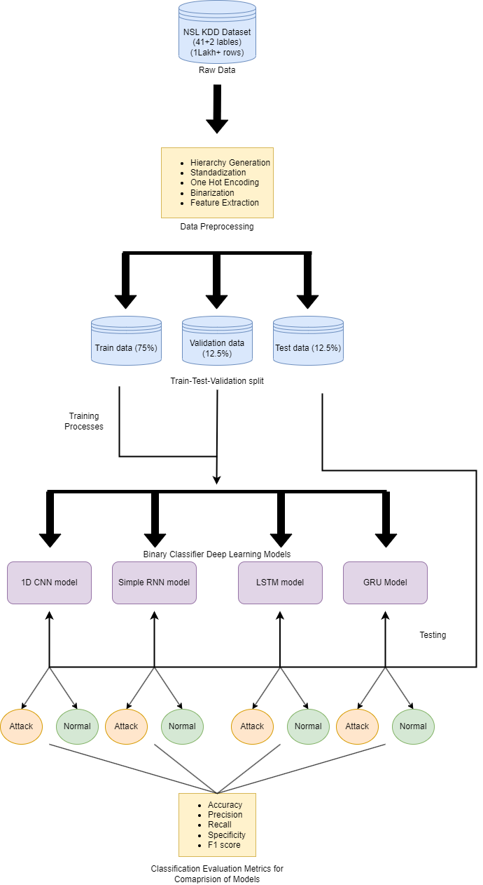

1. Pipeline of proposed model

## Data Pre-processing

The effective utilization of artificial neural network algorithms to identify network intrusion detection relies heavily on data pre-processing. This phase involves the analysis, filtering, transformation, and encoding of data in a way that allows the deep learning classifier to understand and work with the processed output. The quality of the classifier results can be significantly degraded by the presence of unclean data such as missing attributes, attribute values, noise or outliers, and duplicate or incorrect data. Thus, it is essential to manipulate and transform raw data into a useful and efficient format before using it in Artificial Neural Network model to ensure performance. [16][17][18]

To achieve this objective, various data pre-processing techniques are employed. The presence of missing values in a dataset can negatively impact the performance and accuracy of a deep learning model. In order to mitigate this issue, missing values in the data are removed by deleting rows with more than 25 missing features. For rows with fewer missing values, categorical features are replaced with mode and numerical data with mean.

Next, data transformation is performed to produce patterns that are simpler to comprehend by altering its format, structure, or values. The range of raw data values varies widely, and some algorithms do not perform well without feature scaling. Thus, the data value of all numerical features are scaled by subtracting the mean and scaling to unit variance using the StandardScaler class of the sklearn.preprocessing library. Suppose if u represent the mean of the training samples, and s represent the standard deviation of the training samples, standard score of a sample x is calculated using (1).

z = (x-u)/s 

Next, concept hierarchy generation is performed to transform properties from lower to higher in the hierarchy, depending on the prediction feature. In this study, as the model aims to predict only the class of attack, the attribute label, which contains sub-classes of attacks or normal traffic, is converted into either of the four attack classes or normal.

Categorical data is converted into categories, and a dummy encoding is used to encode these categorical variables as numbers, enabling deep learning models to assume correlation between these variables that can produce false results. In the dataset, the data attributes 'protocol_type', 'service', and 'flag' are one-hot encoded using dummy variables.

Furthermore, feature selection is performed to select only a few relevant features in the dataset for generating the deep learning classifier model. Pearson's correlation coefficient for all columns is calculated, and only attributes that have more than 0.5 correlation with encoded attack label attribute are selected for further deep learning model development.[19]

Finally, the dataset is split into train, validation, and test sets in an 75:12.5:12.5 ratio randomly using the train_test_split function in sklearn, with the test dataset used to evaluate results using various metrics. The resulting dataset after merging the KDDTrain and KDDTest datasets contains 148,517 rows, with the train, validation, and test sets containing 111,387, 18,565, and 18,565 rows, respectively.

The distribution of the Normal and Abnormal labels in the dataset was found to be equally distributed with 77,054 rows of the normal class and 71,463 rows of the attack class. A pie chart of the distribution of the Normal and attack classes is shown in Fig 1, which indicates that the dataset is well balanced between the two classes.

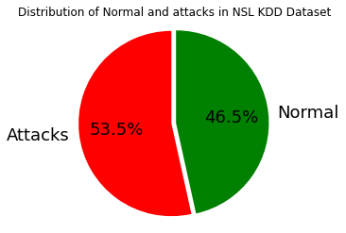

1. Pie Chart distribution of Normal and attacks in dataset

## Artficial Neural Networks

### CNN

Convolutional Neural Networks (CNNs) are a type of artificial neural network that been extensively used in deep learning for binary classification tasks. The key advantage of CNNs over other machine learning algorithms is their ability to learn hierarchical features directly from raw data, without the need for manual feature engineering.[20][21][22].

In this study, a one-dimensional convolutional neural network (1D-CNN) model for binary classification using the Keras library is used. The model architecture is presented in Fig 3 and consists of a total of 9 layers, including an input layer, four 1D convolutional layers, a max pooling layer, a flattening layer, and two fully connected (dense) layers.

The model begins with a 1D convolutional layer that applies 256 filters of kernel size 1 to the input data. The activation function used is hyperbolic tangent (tanh). A second 1D convolutional layer is added with 128 filters of kernel size 1 and tanh activation. A third 1D convolutional layer is added with 64 filters of kernel size 1 and tanh activation. A fourth 1D convolutional layer is added with 32 filters of kernel size 1 and tanh activation. A max pooling layer is added with pool size 1, which reduces the output size. A flatten layer is added to convert the output of the previous layer into a 1D vector. A fully connected (dense) layer with 100 units and ReLU (Rectified Linear Unit) activation function that applies the function in (2) is added.

F(x) = max (0, x) 2

Another fully connected (dense) layer with 2 units and softmax activation is added, which produces the output probabilities for the two classes (binary classification). The Softmax function is given by (3) where K is the number of classes, and xi is the input to the Softmax function for class i.

Softmax(xi) = 2

The model is compiled with binary cross-entropy loss and Adam optimizer, and the metric used for evaluation is accuracy. The equation for binary cross-entropy loss is (3) where y is the true label (either 0 or 1), y' is the predicted probability of the positive class (i.e., the class with label 1), and log is the natural logarithm.

L(y, y') = - [y * log(y') + (1 - y) * log(1 - y')] 3

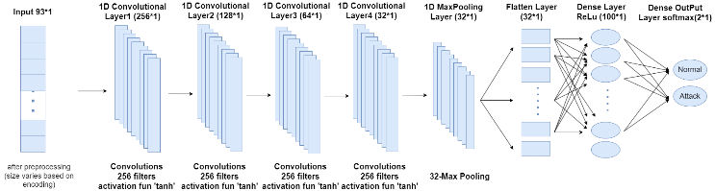

1. CNN Architecture

### RNN

Recurrent Neural Networks (RNNs) have become increasingly popular due to their ability to process sequential data with varying lengths by utilizing internal memory. In this study, a simple RNN architecture for binary classification using the Keras library is used.[23]

The proposed model architecture is presented in Fig 4 and consists of four layers of SimpleRNN cells followed by a Dense layer with a softmax activation function. The first SimpleRNN layer has 256 units, a dropout rate of 0.3, and return_sequences set to True. The default tanh activation function is used in the RNN layer. A second SimpleRNN layer is added with 128 units, a dropout rate of 0.3, and return_sequences set to True. A third SimpleRNN layer is added with 64 units, a dropout rate of 0.3, and return_sequences set to True. Finally, a fourth SimpleRNN layer is added with 32 units, without return_sequences, meaning that only the final output of the RNN layer will be used as input to the next layer. A fully connected (dense) layer with 2 units and softmax activation is added, which produces the output probabilities for the two classes (binary classification). The model is compiled with binary cross-entropy loss and Adam optimizer, and the metric used for evaluation is accuracy.

In the proposed RNN architecture, the input data is processed sequentially, one time step at a time. Each RNN layer has a set of recurrent units that maintain a hidden state, which is updated at each time step based on the input and the previous hidden state. The output of each time step is then used as input for the next time step. The return_sequences parameter set to True in the first three RNN layers means that the output of each time step will be returned as a sequence, which allows the subsequent RNN layers to process the entire sequence of outputs. The last RNN layer has return_sequences set to False, which means that it outputs the final hidden state of the RNN layer.

In an RNN, the input data is processed sequentially, one time step at a time. Each RNN layer in this model has a set of recurrent units that maintain a hidden state, which is updated at each time step based on the input and the previous hidden state. The output of each time step is then used as input for the next time step. The return_sequences parameter set to True in the first three RNN layers means that the output of each time step will be returned as a sequence, which allows the subsequent RNN layers to process the entire sequence of outputs. The last RNN layer has return_sequences set to False, which means that it outputs the final hidden state of the RNN layer.

To prevent overfitting in the RNN layers, the dropout parameter with a rate of 0.3 is used to randomly set a fraction of the inputs to zero during training. The softmax activation function given in (2) used in the output layer produces a probability distribution over the two classes, and binary cross-entropy given in (3) is used as the loss function to train the model to predict the correct class.

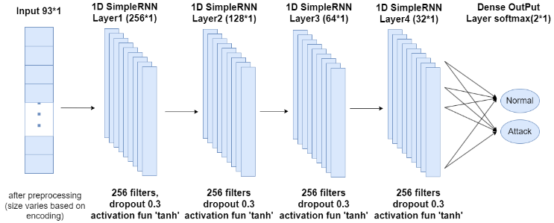

1. RNN Architecture

### LSTM

Long short-term memory (LSTM) is a popular type of artificial neural network that has gained significant attention in recent years due to its ability to handle long-term dependencies in input data. LSTMs are a type of recurrent neural network (RNN) that use feedback connections to process complete data sequences instead of just single data points.[24]

In this study, an LSTM architecture for binary classification using the Keras library is used. The model architecture is presented in the Fig 5 and contains a total of 6 layers: Input layer, 4 LSTM layers, and a Dense layer. The architecture begins with a first layer consisting of 256 units and a dropout rate of 0.3. The return_sequences parameter is set to True, allowing the output of each time step to be returned as a sequence. The default tanh activation function is used for this LSTM layer. A second LSTM layer is added with 128 units, a dropout rate of 0.3, and return_sequences set to True. A third LSTM layer is added with 64 units, a dropout rate of 0.3, and return_sequences set to True. A fourth LSTM layer is added with 32 units, without return_sequences, meaning that only the final output of the LSTM layer will be used as input to the next layer. The final fully connected (dense) layer has 2 units and uses a softmax activation function to produce the output probabilities for the two classes in binary classification.

The LSTM architecture is compiled with binary cross-entropy loss and Adam optimizer, and the evaluation metric used is accuracy. The dropout parameter and input shape are the same as in the RNN model architecture, allowing the LSTM to process input data sequentially, one time step at a time. The return_sequences parameter set to True in the first three LSTM layers allows subsequent LSTM layers to process the entire sequence of outputs, while the last LSTM layer with return_sequences set to False outputs the final hidden state of the LSTM layer.

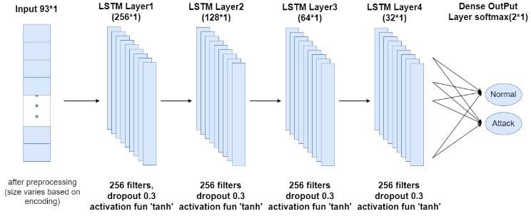

1. LSTM Architecture

### GRU

Gated Recurrent Unit (GRU), is an improved model over the regular Recurrent Neural Network (RNN) by incorporating a gating mechanism. GRU is similar to an LSTM with a forget gate, but it has fewer parameters as it doesn't have an output gate.

In this study, an GRU architecture for binary classification using the Keras library is used. The model architecture the same is presented in Fig 6 and consists of a total of seven layers, including an input layer, four GRU layers, and a dense layer. The four GRU layers are sequentially connected, with a decreasing number of neurons from 256 to 32, while a dropout rate of 0.3 is incorporated to mitigate overfitting.

The input layer takes the input data in the form of a 2D array with a shape of (1, no of columns), where the first dimension corresponds to the time steps and the second dimension corresponds to the features. The second to fourth layers are the GRU layers, which are a type of recurrent neural network (RNN) that are similar to LSTMs but with fewer parameters. The GRU layer includes a reset gate and an update gate, which enable the network to remember or forget previous input data. The GRU layer also utilizes the hidden state to capture the temporal dependencies of the input data. The final layer is a dense layer with 2 neurons, producing the model's output in the form of a probability distribution over the two classes. The softmax activation function is employed to ensure that the model's outputs sum to one. The model is trained with binary cross-entropy as the loss function and the Adam optimizer. Hyperparameters used in all architectures is presented in Table 1.

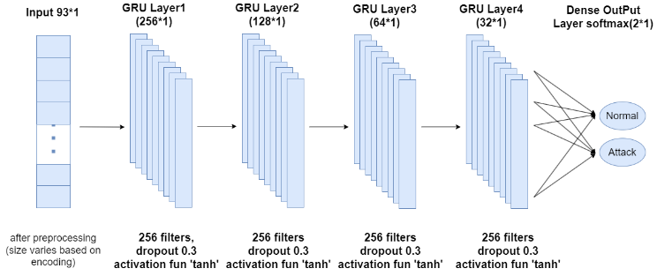

1. GRU Architecture
2. Hyperparameters in different architectures used

|  |  |  |  |  |
| --- | --- | --- | --- | --- |
| **Parameter** | **CNN** | **RNN** | **LSTM** | **GRU** |
| Filters | 256, 128, 64, 32 | 256, 128, 64, 32 | 256, 128, 64, 32 | 256, 128, 64, 32 |
| Kernel size | 1 |  |  |  |
| Activation function | tanh | Default(linear) | default (tanh) | default (tanh) |
| Pooling size | 1 |  |  |  |
| Number of dense layers | 2 | 1 | 1 | 1 |
| Dense layer sizes | 100, 2 | 2 | 2 | 2 |
| Loss function | binary crossentropy | binary crossentropy | binary crossentropy | binary crossentropy |
| Optimizer | adam | adam | adam | adam |
| Dropout rate |  | 0.3 | 0.3 | 0.3 |
| Batch size | 2785 | 2785 | 2785 | 2785 |
| Number of epochs | 100 | 100 | 100 | 100 |

# Experiments and Analysis

## Experimental Set-up

Python has several libraries that are used for data pre-processing and building Deep Learning models, and their names are listed in Table 2. These libraries provide essential support for performing specific tasks required for data analysis and model development.

1. Python Libraries Used

|  |  |
| --- | --- |
| Numpy | Pandas |
| Matplotlib | Seaborn |
| keras | sklearn |
| tensorflow | visualkeras |
| pydot | graphviz |
| pydotplus | sys |

## Study of NSL KDD Dataset

The NSL-KDD dataset was introduced as part of The Third International Knowledge Discovery and Data Mining Tools Competition, which was held alongside KDD-99, The Fifth International Conference on Knowledge Discovery and Data Mining. The primary objective of the competition was to develop a network intrusion detection system capable of accurately distinguishing between "bad" connections, known as intrusions or attacks, and "good" normal connections. The dataset comprises a comprehensive collection of auditable data, including a diverse array of simulated intrusions encountered in a military network environment. It has since become a widely used benchmark dataset in the field of network security and intrusion detection, facilitating the development and evaluation of new and improved models and algorithms.[34]

The dataset can be downloaded from the site <https://www.unb.ca/cic/datasets/nsl.html> .

## Dataset Splits

This data set is comprised of four sub data sets: KDDTest+, KDDTest-21, KDDTrain+, KDDTrain+_20Percent, although KDDTest-21 and KDDTrain+_20Percent are subsets of the KDDTrain+ and KDDTest+.

KDDTrain+ is simply referred to as train and KDDTest+ is referred to as test. The KDDTest-21 is a subset of test, without the most difficult traffic records (Score of 21), and the KDDTrain+_20Percent is a subset of train, whose record count makes up 20% of the entire train dataset. That being said, the traffic records that exist in the KDDTest-21 and KDDTrain+_20Percent are already in test and train respectively and aren’t new records held out of either dataset.

## Features

The dataset contains 4,94,021 tuples and 43 features per record, with 41 referring to the traffic input itself [independent] and the last two being labels (whether the traffic input is normal or attack) and Score (the severity of the traffic input itself) [dependent].

There are 4 different classes of attacks: Denial of Service (DoS), Probe, User to Root(U2R), and Remote to Local (R2L). A brief description of each attack is presented in table 3.

1. Classes of Attacks in NSL KDD Dataset

|  |  |  |
| --- | --- | --- |
| **Attribute** | **Attribute type** | **Purpose** |
| DoS | Explicit | shut down traffic flow from the target system. (IDS is flooded with an abnormal amount of traffic)  Eg: online retailer getting flooded with online orders on a day with a big sale |
| Probe | Implicit | get information from a network  act like a thief and steal important information |
| U2R | Implicit | Exploit the vulnerabilities to gain root privileges  (starts off with a normal user account and tries to gain access to the system or network, as a super-root user) |
| R2L | Implicit | gain local access to a remote machine (kinda hacking) |

Here Important to note is - DoS acts differently from the other three attacks, where DoS attempts to shut down a system to stop traffic flow altogether, whereas the other three attempts to quietly infiltrate the system undetected.

Break- down of sub classes of each attack is presented in the table 4.

1. Sub-Classes of Attacks in NSL KDD Dataset

|  |  |  |
| --- | --- | --- |
| **Classes** | **Sub-Classes** | **Total Count** |
| DoS | apache2, back, land, Neptune, mailbomb, pod, processtable, smurf, teardrop, udpstorm, worm | 11 |
| Proble | Ipsweep, mscan, nmap, portsweep, saint, satan | 6 |
| U2R | Buffer_overflow, loadmodule, perl, ps, rootkit, sqlattack, xterm | 7 |
| R2L | ftp_write, guess_passwd, httptunnel, imap, multihop, named, phf, sendmail, Snmpgetattack, spy, snmpguess, warezclient, warezmaster, xlock, xsnoop | 15 |

Essentially, more than half of the records that exist in each data set are normal traffic, and the distribution of U2R and R2L are extremely low. Although this is low, this is an accurate representation of the distribution of modern-day internet traffic attacks, where the most common attack is DoS and U2R and R2L are hardly ever seen

## Class level Details

The features can be broken down into four categories: Intrinsic, Content, Host-based, and Time-based. The description of it is presented in Table 5.

1. Classification of Features in NSL KDD Dataset

|  |  |  |
| --- | --- | --- |
| **Category** | **Description** | **Features** |
| Intrinsic features | These can be derived from the header of the packet without looking into the payload itself, and hold the basic information about the packet. | Features 1-9 |
| Content features | These hold information about the original packets, as they are sent in multiple pieces rather than one. With this information, the system can access the payload. This category contains features 10–22. | Features 10-22 |
| Time-based features | These features hold the analysis of the traffic input over a two-second window and contain information like how many connections it attempted to make to the same host. These features are mostly counts and rates rather than information about the content of the traffic input | Features 23-31 |
| Host-based features | These features are similar to Time-based features, except instead of analyzing over a 2-second window, it analyzes over a series of connections made (how many requests made to the same host over x-number of connections). These features are designed to access attacks, which span longer than a two-second window time-span. | Features 32-41 |

## Feature Types

These features types can be broken down into Categorical, Binary, Discrete and Continuous

#### 4 Categorical (Features: 2, 3, 4, 42)

#### 6 Binary (Features: 7, 12, 14, 20, 21, 22)

#### 23 Discrete (Features: 8, 9, 15, 23–41, 43)

#### 10 Continuous (Features: 1, 5, 6, 10, 11, 13, 16, 17, 18, 19)

The detailed description about each feature in dataset is presented in Appendix I.

# Results and Discussion

A total of 25,192 data with 41 features was taken from the NSL-KDD dataset for training. The 3 symbolic features (protocol, service, flag) were expanded using 1-N encoding. Then the dataset is standardized with differencing with mean and dividing by standard deviation. Then only 10 features with high correlation with the intrusion column was chosen. The final data contains 93 features, it is subject to vary depending on encoding categories.

## Performance Metrics

The performance of the model is evaluated using the confusion matrix. The following factors are taken into account. True Positive (TP) denotes the correct classification of the attack. A False Positive (FP) is when a normal network is misclassified as an attack. A True Negative (NP) is a correctly classifying normal attack as normal, whereas a False Negative (FN) is the case when the attack is incorrectly identified as a normal network. The various metrics are presented below in (4) to (8) where, TP is number of true positives, TN is number of true negatives, FP is number of false positives, FN is number of false negatives.

1. The accuracy is defined as the proportion of accurately predicted values to total number of test cases.

Accuracy = TP+TN/TP+TN+FP+FN 4

1. The precision is defined as the proportion of accurately predicted positive values to total number of predicted positive values.

Precision = TP/TP+FP 5

1. The recall is defined as the proportion of accurately predicted positive values to the total number of positive values.

Recall = TP/TP+FN 6

1. The Specificity is defined as the proportion of accurately predicted negative test results to the total number of all truly negative values.

Specificity = TN/TN+FP 7

1. F1-score metric combines the precision and recall of a classifier into a single measure. F1-score is calculated by taking harmonic mean of Precision and Recall

F1-Score = 2*(Precision*Recall)/(Precision + Recall) 8

## Performance of Each model

### CNN

The performance metrics of the CNN model is presented in table VI. The Classification report, Confusion matrix, Accuracy graph, Loss graph and ROC curve for the same are also shown in Fig 6, Fig 7, Fig 8, Fig 9 and Fig 10 respectively.

The CNN model has the highest accuracy score of 0.978, which suggests that it classified almost 98% of the instances correctly. The precision score of 0.973 indicates that out of all the instances classified as positive, 97% of them were actually positive. The recall/sensitivity score of 0.986 suggests that out of all the actual positive instances, the model was able to correctly identify almost 99% of them. The specificity score of 0.971 implies that out of all the actual negative instances, the model was able to correctly identify about 97% of them. The F1 score of 0.979 is a measure of the balance between precision and recall, and it is relatively high for this model.

The accuracy graph of the CNN model shows a gradual increase in accuracy as the number of epochs increases, with a final accuracy of almost 98%. The loss function of the CNN model also shows a steady decrease over the epochs, indicating that the model is learning and improving its performance. The ROC curve of the CNN model shows a steep rise from the origin, indicating that the model has a high true positive rate and a low false positive rate. The curve also shows a steep increase in the AUC score, suggesting that the model has high discriminatory power and is able to distinguish between positive and negative instances effectively. Overall, these metrics suggest that the CNN model performed very well in classifying both positive and negative instances, and it may be a suitable choice for this binary classification task.

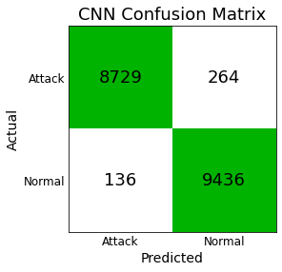

1. CNN Model Confusion Matrix

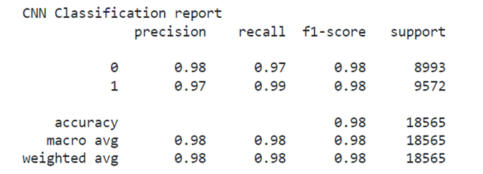

1. 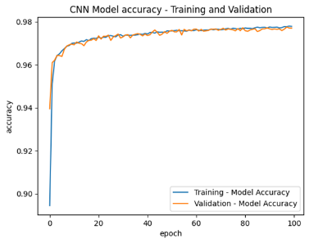CNN Classification Report

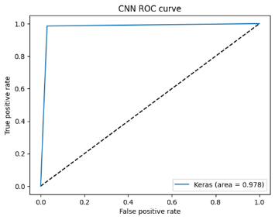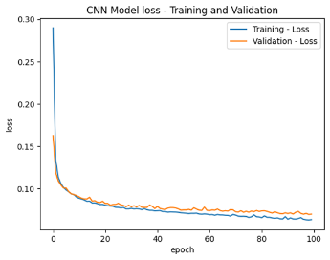

1. (a) Model Accuracy graph, (b) Model Loss graph, (c) ROC Curve of CNN Model (from right top to bottom)
2. Results of CNN Model (in %)

|  |  |
| --- | --- |
| Accuracy | 97.84 |
| Precision | 97.27 |
| Recall | 98.57 |
| Specificity | 97.06 |
| F1 Score | 97.92 |

### RNN

The performance metrics of the RNN model is presented in table VII. The Classification report, Confusion matrix, Accuracy graph, Loss graph and ROC curve for the same are also shown in Fig 11, Fig 12, Fig 13, Fig 14 and Fig 15 respectively.

The RNN model has an accuracy score of 0.967, which is slightly lower than that of the CNN model. The precision score of 0.956 indicates that out of all the instances classified as positive, 96% of them were actually positive. The recall/sensitivity score of 0.982 suggests that out of all the actual positive instances, the model was able to correctly identify about 98% of them. The specificity score of 0.951 implies that out of all the actual negative instances, the model was able to correctly identify about 95% of them. The F1 score of 0.969 is relatively high for this model, indicating a good balance between precision and recall.

The accuracy graph of the RNN model shows a steady increase in accuracy over the initial epochs, but it appears to plateau after the 20th epoch, with values fluctuating around 97.5%. There is no indication of a decrease in accuracy. The loss function of the RNN model shows a gradual decrease over the epochs, which suggests that the model is learning and improving its performance. The ROC curve of the RNN model shows a gradual rise from the origin, indicating that the model has a moderate true positive rate and a moderate false positive rate. The curve also shows a moderate increase in the AUC score, which suggests that the model has some discriminatory power but may not be as effective as the CNN model.

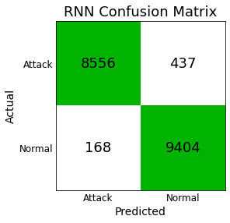

1. RNN Confusion Matrix

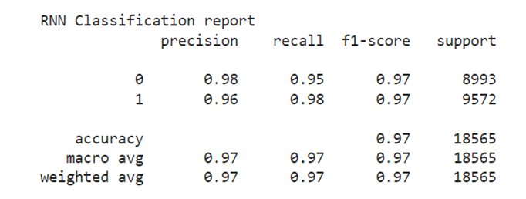

1. 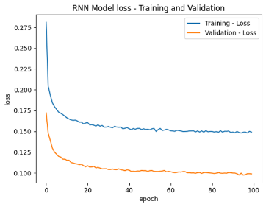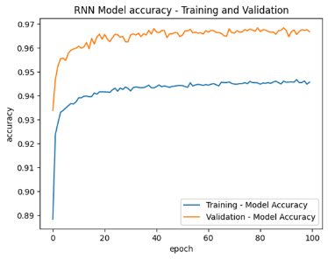RNN Classification Report

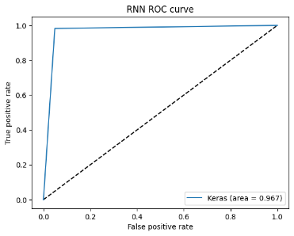

1. (a) Model Accuracy, (b) Model Loss, (c) ROC Curve of RNN model (from right top to bottom)
2. Results of RNN Model

|  |  |
| --- | --- |
| Accuracy | 96.74 |
| Precision | 95.55 |
| Recall | 98.24 |
| Specificity | 95.14 |
| F1 Score | 96.88 |

### LSTM

The performance metrics of the LSTN model is presented in table VIII. The Classification report, Confusion matrix, Accuracy graph, Loss graph and ROC curve for the same are also shown in Fig 16, Fig 17, Fig 18, Fig 19 and Fig 20 respectively.

The LSTM model has an accuracy score of 0.968, which is similar to that of the RNN model. The precision score of 0.956 indicates that out of all the instances classified as positive, 96% of them were actually positive. The recall/sensitivity score of 0.983 suggests that out of all the actual positive instances, the model was able to correctly identify almost 98.5% of them. The specificity score of 0.951 implies that out of all the actual negative instances, the model was able to correctly identify about 95% of them. The F1 score of 0.969 is also similar to that of the RNN model, indicating a good balance between precision and recall.

The accuracy graph of the LSTM model shows a gradual increase in accuracy over the initial epochs, but it appears to plateau after the 15th epoch, with values fluctuating around 97.7%. The loss function of the LSTM model shows a gradual decrease over the epochs, which suggests that the model is learning and improving its performance. The ROC curve of the LSTM model shows a gradual rise from the origin, indicating that the model has a moderate true positive rate and a moderate false positive rate. Overall, these metrics suggest that the LSTM model is also performing well, but its performance is very similar to that of the RNN model.

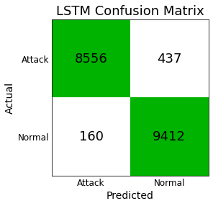

1. LSTM Confusion Matrix

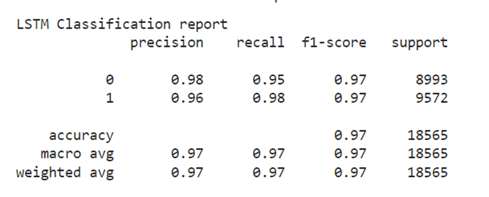

1. 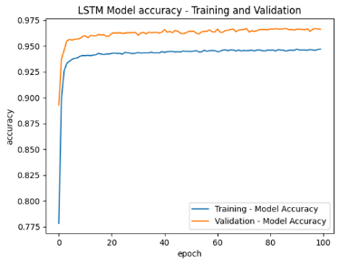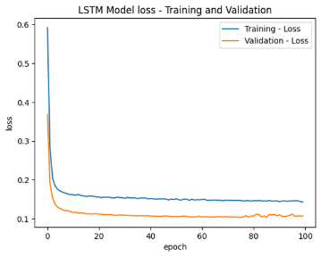LSTM Classification Report

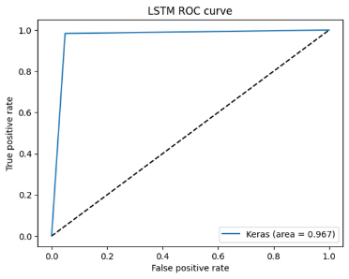

1. (a) LSTM Model Accuracy, (b) Model Loss Graph, (c) ROC Curve of LSTM model (from right top to bottom)
2. Results of LSTM Model

|  |  |
| --- | --- |
| Accuracy | 96.78 |
| Precision | 95.56 |
| Recall | 98.32 |
| Specificity | 95.14 |
| F1 Score | 96.92 |

### GRU

The performance metrics of the GRU model is presented in table IX. The Classification report, Confusion matrix, Accuracy graph, Loss graph and ROC curve for the same are also shown in Fig 21, Fig 22, Fig 23, Fig 24 and Fig 25 respectively.

The GRU model has the lowest accuracy score of 0.965, which is slightly lower than that of the RNN and LSTM models. The precision score of 0.948 indicates that out of all the instances classified as positive, 94.8% of them were actually positive. The recall/sensitivity score of 0.985 suggests that out of all the actual positive instances, the model was able to correctly identify almost 99% of them. The specificity score of 0.942 implies that out of all the actual negative instances, the model was able to correctly identify about 94% of them. The F1 score of 0.966 is the lowest among the four models, indicating that there is some imbalance between precision and recall.

The accuracy graph of the GRU model shows a steady increase in accuracy over the initial epochs, but it appears to plateau after the 20th epoch, with values highly fluctuating around 96.5%. The loss function of the GRU model shows a gradual decrease over the epochs with slight flucatuations after 85th epoch, which suggests that the model is learning and improving its performance. The ROC curve of the GRU model shows a gradual rise from the origin, indicating that the model has a moderate true positive rate and a moderate false positive rate. Overall, these metrics suggest that the GRU model is performing well in identifying actual positive instances, but it has a relatively high false positive rate, which could impact its overall accuracy.

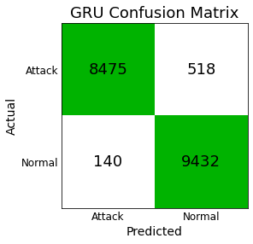

1. GRU Confusion Matrix

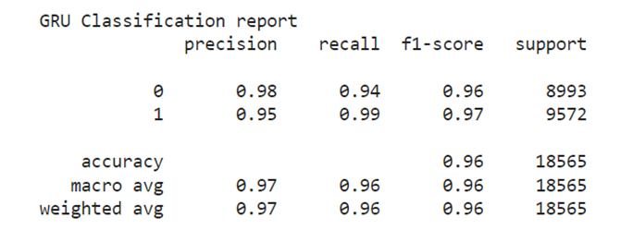

1. GRU Classification Report

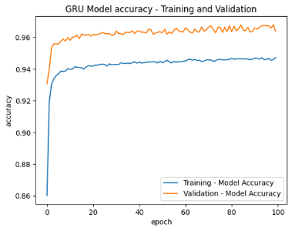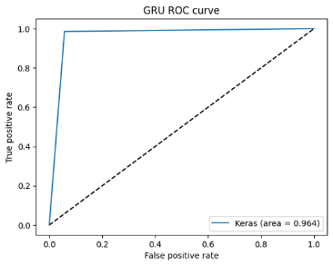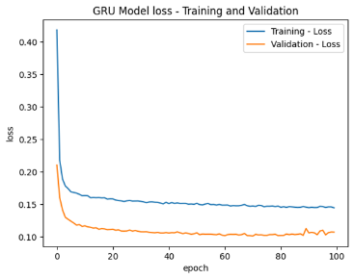

1. (a) GRU Accuracy Model , (b) Model Loss Graph, (c) ROC Curve in GRU model (from right top to bottom)
2. Results of GRU Model

|  |  |
| --- | --- |
| Accuracy | 96.45 |
| Precision | 94.79 |
| Recall | 98.53 |
| Specificity | 94.23 |
| F1 Score | 96.62 |

## Results Comparision

Comparison of all 4 model’s Confusion matrix and performance metrics is summarized in Table X and Table XI. Fig 26 presents the comparison of various binary classification performance metrics using Bar Graph.

It can be interfered that, all four models are performing relatively well, with accuracy scores ranging from 0.965 to 0.978. The CNN model has the highest accuracy score, and the GRU model has the lowest accuracy score. However, the precision, recall, specificity, and F1 scores of the four models are all relatively close to each other. The CNN model has the highest F1 score of 0.979, indicating a good balance between precision and recall, while the GRU model has the lowest F1 score of 0.966, indicating some imbalance between precision and recall.

To quantify the improvement of each model over the lowest-performing model (GRU), the percentage and absolute improvements in accuracy and F1 score can be used. The CNN model has a relative improvement of 1.33% in accuracy and 1.30% in F1 score compared to LSTM, the second-best performing model. In absolute terms, the CNN model has an improvement of 1.12% in accuracy and 0.71% in F1 score compared to LSTM. The LSTM model has a relative improvement of 0.11% in accuracy and 0.46% in F1 score compared to RNN, and an absolute improvement of 0.01% in accuracy and 0.29% in F1 score. The RNN model has a relative improvement of 0.41% in accuracy and 1.19% in F1 score compared to GRU, and an absolute improvement of 0.29% in accuracy and 0.99% in F1 score.

The training duration shows that the CNN model had the shortest runtime at 3 minutes and 4 seconds, followed by the GRU model at 17 minutes and 35 seconds, then the RNN model at 6 minutes and 28 seconds, and finally the LSTM model with the longest runtime at 31 minutes and 38 seconds.

Therefore, based on these metrics, the CNN model appears to be the best performing model, followed closely by the RNN and LSTM models, with the GRU model lagging behind. [25][26].

The CNN model may have performed better than the LSTM model which is best for most of the applications due to its parameter efficiency, which allows it to extract features more efficiently. Additionally, the specific hyperparameters used in the CNN model may have been better suited for the problem, and the use of max-pooling layers and dropout regularization in the CNN model may have helped prevent overfitting.

1. Results Comparision of all Models

|  |  |  |  |  |
| --- | --- | --- | --- | --- |
|  | TP | FP | FN | TN |
| CNN | 8729 | 264 | 136 | 9436 |
| RNN | 8556 | 437 | 168 | 9404 |
| LSTM | 8556 | 437 | 160 | 9412 |
| GRU | 8475 | 518 | 140 | 9432 |

1. Results Comapision Matrics of all Model

|  |  |  |  |  |
| --- | --- | --- | --- | --- |
|  | CNN | RNN | LSTM | GRU |
| Accuracy | **97.84** | 96.74 | 96.78 | 96.45 |
| Precision | **97.27** | 95.55 | 95.56 | 94.79 |
| Recall | **98.57** | 98.24 | 98.32 | 98.53 |
| Specificity | **97.06** | 95.14 | 95.14 | 94.23 |
| F1 Score | **97.92** | 96.88 | 96.92 | 96.62 |

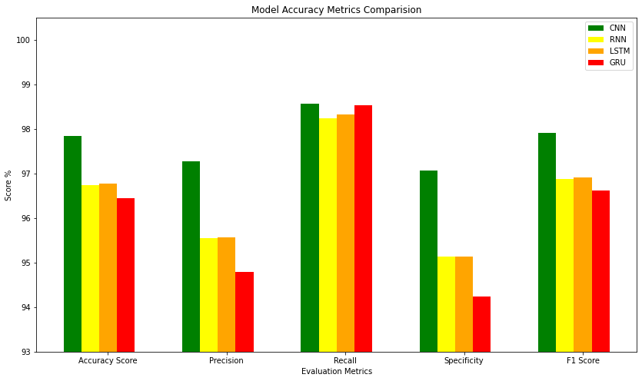

1. Comparision bargraph of all model metrics

# Conclusion and Future Scope

A study on binary classification of intrusion detection using deep learning models on the NSL-KDD dataset found that the CNN model performed best, followed closely by the RNN and LSTM models. The study evaluated the models using various performance metrics and provides insights into their effectiveness for intrusion detection, aiding researchers in selecting appropriate models based on their needs. The study establishes a standard baseline for future research in intrusion detection using deep learning models on the widely used NSL-KDD dataset.

Future scope of this research work could involve exploring other deep learning architectures or hybrid models to improve the accuracy and performance of intrusion detection systems. Additionally, expanding the dataset to include more diverse and complex cyber-attacks could help to create more robust models for intrusion detection. Furthermore, exploring the use of transfer learning, data augmentation, and ensembling techniques could help to improve the performance of deep learning models for intrusion detection. Overall, this research work provides a solid foundation for further exploration and development of deep learning-based intrusion detection systems.

# References

1. A. Alshamrani, S. Myneni, A. Chowdhary and D. Huang, "A Survey on Advanced Persistent Threats: Techniques, Solutions, Challenges, and Research Opportunities," in IEEE Communications Surveys & Tutorials, vol. 21, no. 2, pp. 1851-1877, Secondquarter 2019, doi: 10.1109/COMST.2019.2891891
2. Atif Ahmad, Jeb Webb, Kevin C. Desouza, James Boorman, Strategically-motivated advanced persistent threat: Definition, process, tactics and a disinformation model of counterattack, Computers & Security, Volume 86, 2019, Pages 402-418, ISSN 0167-4048, doi: 10.1016/j.cose.2019.07.001.T.
3. A. Tang, L. Mhamdi, D. McLernon, S. A. R. Zaidi and M. Ghogho, "Deep learning approach for Network Intrusion Detection in Software Defined Networking," 2016 International Conference on Wireless Networks and Mobile Communications (WINCOM), 2016, pp. 258-263, doi: 10.1109/WINCOM.2016.7777224.
4. J. Hassannataj Joloudari, M. Haderbadi, A. Mashmool, M. Ghasemigol, S. S. Band and A. Mosavi, "Early Detection of the Advanced Persistent Threat Attack Using Performance Analysis of Deep Learning," in IEEE Access, vol. 8, pp. 186125-186137, 2020, doi: 10.1109/ACCESS.2020.3029202.
5. Chu W-L, Lin C-J, Chang K-N. Detection and Classification of Advanced Persistent Threats and Attacks Using the Support Vector Machine. Applied Sciences. 2019; 9(21):4579. Doi: 10.3390/app9214579
6. H. N. Ooi and N. H. Ab Rahman, “A Comparative Study between Deep Learning Algorithm and Bayesian Network on Advanced Persistent Threat(APT) Attack Detection”., aitcs, vol. 2, no. 2, pp. 219–235, Nov. 2021.
7. A. Khalid, A. Zainal, M. A. Maarof and F. A. Ghaleb, "Advanced Persistent Threat Detection: A Survey," 2021 3rd International Cyber Resilience Conference (CRC), Langkawi Island, Malaysia, 2021, pp. 1-6, doi: 10.1109/CRC50527.2021.9392626.
8. Weina Niu, Jie Zhou, Yibin Zhao, Xiaosong Zhang, Yujie Peng, Cheng Huang, Uncovering APT malware traffic using deep learning combined with time sequence and association analysis, Computers & Security, Volume 120, 2022, 102809, ISSN 0167-4048, doi: 10.1016/j.cose.2022.102809.
9. Michael Zipperle, Florian Gottwalt, Elizabeth Chang, and Tharam Dillon. 2022. Provenance-based Intrusion Detection Systems: A Survey. ACM Comput. Surv. 55, 7, Article 135 (July 2023), 36 pages. https://doi.org/10.1145/3539605
10. T. Bodström and T. Hämäläinen, “A Novel Deep Learning Stack for APT Detection,” Applied Sciences, vol. 9, no. 6, p. 1055, Mar. 2019, doi: 10.3390/app9061055.
11. H. Hindy et al., "A Taxonomy of Network Threats and the Effect of Current Datasets on Intrusion Detection Systems," in IEEE Access, vol. 8, pp. 104650-104675, 2020, doi: 10.1109/ACCESS.2020.3000179.
12. HADI, MHMOOD, A Novel Approach to Network Intrusion Detection System Using Deep Learning for Sdn: Futuristic Approach (July 11, 2022). Available at SSRN: doi: 10.2139/ssrn.4160050
13. P. Singh, J. J. P, A. Pankaj and R. Mitra, "Edge-Detect: Edge-Centric Network Intrusion Detection using Deep Neural Network," 2021 IEEE 18th Annual Consumer Communications & Networking Conference (CCNC), 2021, pp. 1-6, doi: 10.1109/CCNC49032.2021.9369469.
14. F. Z. Belgrana, N. Benamrane, M. A. Hamaida, A. Mohamed Chaabani and A. Taleb-Ahmed, "Network Intrusion Detection System Using Neural Network and Condensed Nearest Neighbors with Selection of NSL-KDD Influencing Features," 2020 IEEE International Conference on Internet of Things and Intelligence System (IoTaIS), 2021, pp. 23-29, doi: 10.1109/IoTaIS50849.2021.9359689.
15. Kesavulu Reddy, Dr. (2013). Neural Networks for Intrusion Detection and Its Applications. Lecture Notes in Engineering and Computer Science. 2. 1210-1214.
16. Sharma, S., Gigras, Y., Chhikara, R. and Dhull, A., 2019. Analysis of NSL KDD dataset using classification algorithms for intrusion detection system. Recent Patents on Engineering, 13(2), pp.142-147. 12. 10.2174/1872212112666180402122150.
17. R. Thomas and D. Pavithran, "A Survey of Intrusion Detection Models based on NSL-KDD Data Set," 2018 Fifth HCT Information Technology Trends (ITT), 2018, pp. 286-291, doi: 10.1109/CTIT.2018.8649498.
18. M. Srikanth Yadav. and R. Kalpana., "Data Preprocessing for Intrusion Detection System Using Encoding and Normalization Approaches," 2019 11th International Conference on Advanced Computing (ICoAC), 2019, pp. 265-269, doi: 10.1109/ICoAC48765.2019.246851.
19. J. -h. Woo, J. -Y. Song and Y. -J. Choi, "Performance Enhancement of Deep Neural Network Using Feature Selection and Preprocessing for Intrusion Detection," 2019 International Conference on Artificial Intelligence in Information and Communication (ICAIIC), Okinawa, Japan, 2019, pp. 415-417, doi: 10.1109/ICAIIC.2019.8668995.
20. Yalei Ding and Yuqing Zhai. 2018. Intrusion Detection System for NSL-KDD Dataset Using Convolutional Neural Networks. In Proceedings of the 2018 2nd International Conference on Computer Science and Artificial Intelligence (CSAI '18). Association for Computing Machinery, New York, NY, USA, 81–85. doi : 10.1145/3297156.3297230
21. Ravi, Vinayakumar & Kp, Soman & Poornachandran, Prabaharan. (2017). Applying convolutional neural network for network intrusion detection. 1222-1228. 10.1109/ICACCI.2017.8126009.
22. X. Zhang, J. Ran and J. Mi, "An Intrusion Detection System Based on Convolutional Neural Network for Imbalanced Network Traffic," 2019 IEEE 7th International Conference on Computer Science and Network Technology (ICCSNT), 2019, pp. 456-460, doi: 10.1109/ICCSNT47585.2019.8962490.
23. Muder Almiani, Alia AbuGhazleh, Amer Al-Rahayfeh, Saleh Atiewi, Abdul Razaque, Deep recurrent neural network for IoT intrusion detection system, Simulation Modelling Practice and Theory, Volume 101, 2020, 102031, ISSN 1569-190X, doi: 10.1016/j.simpat.2019.102031.
24. Hsu, CM., Hsieh, HY., Prakosa, S.W., Azhari, M.Z., Leu, JS. (2019). Using Long-Short-Term Memory Based Convolutional Neural Networks for Network Intrusion Detection. In: Chen, JL., Pang, AC., Deng, DJ., Lin, CC. (eds) Wireless Internet. WICON 2018. Lecture Notes of the Institute for Computer Sciences, Social Informatics and Telecommunications Engineering, vol 264. Springer, Cham. https://doi.org/10.1007/978-3-030-06158-6_9
25. T. Su, H. Sun, J. Zhu, S. Wang and Y. Li, "BAT: Deep Learning Methods on Network Intrusion Detection Using NSL-KDD Dataset," in IEEE Access, vol. 8, pp. 29575-29585, 2020, doi: 10.1109/ACCESS.2020.2972627.
26. Ding, Yalei & Zhai, Yuqing. (2018). Intrusion Detection System for NSL-KDD Dataset Using Convolutional Neural Networks. CSAI '18: Proceedings of the 2018 2nd International Conference on Computer Science and Artificial Intelligence. 81-85. 10.1145/3297156.3297230.
27. S. K. Sahu, S. Sarangi and S. K. Jena, "A detail analysis on intrusion detection datasets," 2014 IEEE International Advance Computing Conference (IACC), 2014, pp. 1348-1353, doi: 10.1109/IAdCC.2014.6779523.
28. Ghurab, Mossa & Gaphari, Ghaleb & Alshami, Faisal & Alshamy, Reem & Othman, Suad. (2021). A Detailed Analysis of Benchmark Datasets for Network Intrusion Detection System.
29. I. Abrar, Z. Ayub, F. Masoodi and A. M. Bamhdi, "A Machine Learning Approach for Intrusion Detection System on NSL-KDD Dataset," 2020 International Conference on Smart Electronics and Communication (ICOSEC), 2020, pp. 919-924, doi: 10.1109/ICOSEC49089.2020.9215232.
30. R. Feng, S. Chen, X. Xie, G. Meng, S. -W. Lin and Y. Liu, "A Performance-Sensitive Malware Detection System Using Deep Learning on Mobile Devices," in IEEE Transactions on Information Forensics and Security, vol. 16, pp. 1563-1578, 2021, doi: 10.1109/TIFS.2020.3025436.
31. Wang, Yajing & Ma, Juan & Sharma, Ashutosh & Singh, Pradeep & Gaba, Gurjot & Masud, Mehedi & Baz, Mohammed. (2021). An Exhaustive Research on the Application of Intrusion Detection Technology in Computer Network Security in Sensor Networks. Journal of Sensors. 2021. 1-11. 10.1155/2021/5558860.
32. Sarika Choudhary, Nishtha Kesswani, Analysis of KDD-Cup’99, NSL-KDD and UNSW-NB15 Datasets using Deep Learning in IoT, Procedia Computer Science, Volume 167, 2020, Pages 1561-1573, ISSN 1877-0509, doi: 10.1016/j.procs.2020.03.367.
33. Dorogovs, Pjotrs & Borisov, Arkady & Romanovs, Andrejs. (2011). Building an Intrusion Detection System for IT Security Based on Data Mining Techniques. Scientific Journal of Riga Technical University. Computer Sciences. 45. 10.2478/v10143-011-0040-3
34. Dhanabal, L. and S. P. Shantharajah. “A Study on NSL-KDD Dataset for Intrusion Detection System Based on Classification Algorithms.” (2015).[1]

# Appendix - I

1. Description of Features in NSL KDD Dataset

|  |  |  |  |  |  |
| --- | --- | --- | --- | --- | --- |
| # | **Feature Name** | **Description** | **Type** | **Value Type** | **Ranges** |
| 1 | Duration | Length of time duration of the connection | Continuous | Integers | 0 - 54451 |
| 2 | Protocol Type | Protocol used in the connection | Categorical | Strings |  |
| 3 | Service | Destination network service used | Categorical | Strings |  |
| 4 | Flag | Status of the connection – Normal or Error | Categorical | Strings |  |
| 5 | Src Bytes | Number of data bytes transferred from source to destination in single connection | Continuous | Integers | 0 - 1379963888 |
| 6 | Dst Bytes | Number of data bytes transferred from destination to source in single connection | Continuous | Integers | 0 - 309937401 |
| 7 | Land | If source and destination IP addresses and port numbers are equal then, this variable takes value 1 else 0 | Binary | Integers | {0, 1} |
| 8 | Wrong Fragment | Total number of wrong fragments in this connection | Discrete | Integers | {0,1,3} |
| 9 | Urgent | Number of urgent packets in this connection. Urgent packets are packets with the urgent bit activated | Discrete | Integers | 0 - 3 |
| 10 | Hot | Number of “hot‟ indicators in the content such as: entering a system directory, creating programs and executing programs | Continuous | Integers | 0 - 101 |
| 11 | Num Failed Logins | Count of failed login attempts | Continuous | Integers | 0 - 4 |
| 12 | Logged In | Login Status: 1 if successfully logged in; 0 otherwise | Binary | Integers | {0, 1} |
| 13 | Num Compromised | Number of "compromised” conditions | Continuous | Integers | 0 - 7479 |
| 14 | Root Shell | 1 if root shell is obtained; 0 otherwise | Binary | Integers | {0 , 1} |
| 15 | Su Attempted | 1 if "su root'' command attempted or used; 0 otherwise | Discrete |  |  |
| 16 | (Dataset contains ‘2’ value) | Integers | 0 - 2 |  |  |
| 17 | Num Root | Number of "root'' accesses or number of operations performed as a root in the connection | Continuous | Integers | 0 - 7468 |
| 18 | Num File Creations | Number of file creation operations in the connection | Continuous | Integers | 0 - 100 |
| 19 | Num Shells | Number of shell prompts | Continuous | Integers | 0 - 2 |
| 20 | Num Access Files | Number of operations on access control files | Continuous | Integers | 0 - 9 |
| 21 | Num Outbound Cmds | Number of outbound commands in an ftp session | Continuous | Integers | {0} |
| 22 | Is Hot Logins | 1 if the login belongs to the "hot'' list i.e., root or admin; else 0 | Binary | Integers | {0, 1} |
| 23 | Is Guest Login | 1 if the login is a "guest'' login; 0 otherwise | Binary | Integers | {0, 1} |
| 24 | Count | Number of connections to the same destination host as the current connection in the past two seconds | Discrete | Integers | 0 - 511 |
| 25 | Srv Count | Number of connections to the same service (port number) as the current connection in the past two seconds | Discrete | Integers | 0 - 511 |
| 26 | Serror Rate | The percentage of connections that have activated the flag (4) s0, s1, s2 or s3, among the connections aggregated in count (23) | Discrete | Floats (hundredths of a decimal) | 0 - 1 |
| 27 | Srv Serror Rate | The percentage of connections that have activated the flag (4) s0, s1, s2 or s3, among the connections aggregated in srv_count (24) | Discrete | Floats (hundredths of a decimal) | 0 - 1 |
| 28 | Rerror Rate | The percentage of connections that have activated the flag (4) REJ, among the connections aggregated in count (23) | Discrete | Floats (hundredths of a decimal) | 0 - 1 |
| 29 | Srv Rerror Rate | The percentage of connections that have activated the flag (4) REJ, among the connections aggregated in srv_count (24) | Discrete | Floats (hundredths of a decimal) | 0 - 1 |
| 30 | Same Srv Rate | The percentage of connections that were to the same service, among the connections aggregated in count (23) | Discrete | Floats (hundredths of a decimal) | 0 - 1 |
| 31 | Diff Srv Rate | The percentage of connections that were to different services, among the connections aggregated in count (23) | Discrete | Floats (hundredths of a decimal) | 0 - 1 |
| 32 | Srv Diff Host Rate | The percentage of connections that were to different destination machines among the connections aggregated in srv_count (24) | Discrete | Floats (hundredths of a decimal) | 0 - 1 |
| 33 | Dst Host Count | Number of connections having the same destination host IP address | Discrete | Integers | 0 - 255 |
| 34 | Dst Host Srv Count | Number of connections having the same port number | Discrete | Integers | 0 - 255 |
| 35 | Dst Host Same Srv Rate | The percentage of connections that were to different services, among the connections aggregated in dst_host_count (32) | Discrete | Floats (hundredths of a decimal) | 0 - 1 |
| 36 | Dst Host Diff Srv Rate | The percentage of connections that were to different services, among the connections aggregated in dst_host_count (32) | Discrete | Floats (hundredths of a decimal) | 0 - 1 |
| 37 | Dst Host Srv Diff Host Rate | The percentage of connections that were to different destination machines, among the connections aggregated in dst_host_srv_count (33) | Discrete | Floats (hundredths of a decimal) | 0 - 1 |
| 38 | Dst Host Serror Rate | The percentage of connections that have activated the flag (4) s0, s1, s2 or s3, among the connections aggregated in dst_host_count (32) | Discrete | Floats (hundredths of a decimal) | 0 - 1 |
| 39 | Dst Host Srv Serror Rate | The percent of connections that have activated the flag (4) s0, s1, s2 or s3, among the connections aggregated in dst_host_srv_count (33) | Discrete | Floats (hundredths of a decimal) | 0 - 1 |
| 40 | Dst Host Rerror Rate | The percentage of connections that have activated the flag (4) REJ, among the connections aggregated in dst_host_count (32) | Discrete | Floats (hundredths of a decimal) | 0 - 1 |
| 41 | Dst Host Srv Rerror Rate | The percentage of connections that have activated the flag (4) REJ, among the connections aggregated in dst_host_srv_count (33) | Discrete | Floats (hundredths of a decimal) | 0 - 1 |
| 42 | Class | Classification of the traffic input | Categorical | Strings |  |
| 43 | Difficulty Level | Difficulty level | Discrete | Integers | 0 - 21 |
| 44 | Dst Host Srv Diff Host Rate | The percentage of connections that were to different destination machines, among the connections aggregated in dst_host_srv_count (33) | Discrete | Floats (hundredths of a decimal) | 0 - 1 |

1. <https://github.com/dharaneishvc/APT-detection-Deep-Learning-IBM>